BRICK ORDER FORM

Purchaser’s Name:
Street:
City, State, Zip:
Phone:
Email:

INFORMATION TO BE ENGRAVED ON A BRICK.
Up to 18 characters per line.
Spaces and punctuation are considered characters.

PLEASE PRINT CLEARLY

4” X 8” (up to 3 lines) --------- 8” X 8” BRICK (up to 6 lines)

for office use only:

date received:
amount: cash check online
brick replica
30TH ANNIVERSARY PRAYER GARDEN
You can permanently remember a loved one or honor your family, friends, or anniversary by purchasing a commemorative brick.
Purchasing a brick is a great way to leave a lasting legacy here at Saint Paul the Apostle for those who have gone before us or a way to honor those still among us.
Anniversary Prayer Garden is located at the North-West Lawn; within the outdoor Stations of the Cross. The Carmelite Cypress is its center.
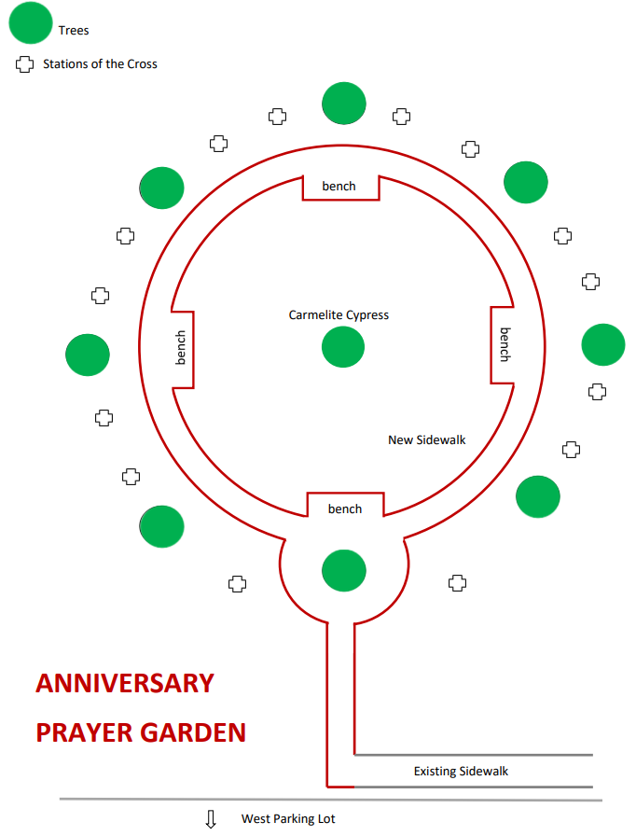
Fill out the Brick Order Form, and:
- pay online and attach the form online
- print this form and:
- send it with payment via mail to:
St. Paul the Apostle
6401 Gages Lake Rd,
Gurnee, IL 60031
- drop it into the collection box
or at Parish House
Bricks will be placed randomly in the garden.

Pricing:
- 4” x 8” brick - $200
- brick + replica - $250*
- 8” x 8” brick - $400
- brick + replica - $500*

* Two similar engraved bricks will be ordered: one brick will be installed at SPA, and another brick is for you to take home.

